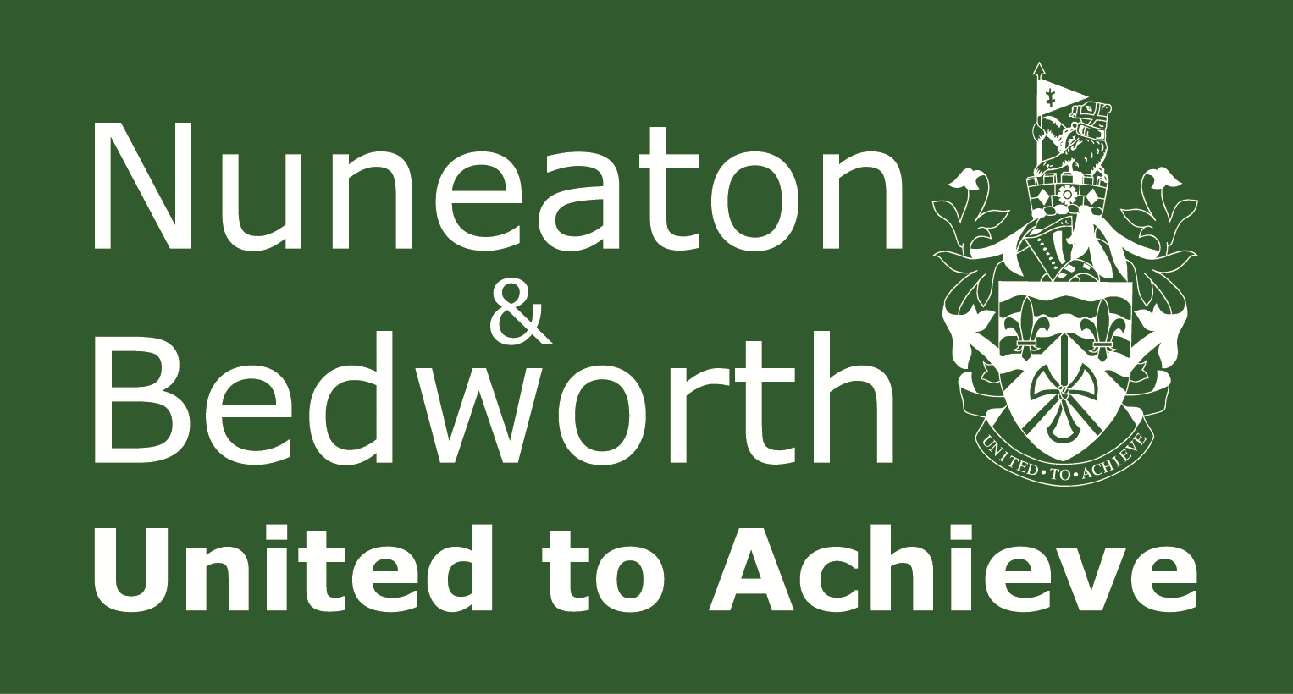 | Climate Change and Sustainability Action Plan  Response  Form | Ref:  (For  official  use only)

Please return to Nuneaton and Bedworth Borough Council by 14th July 2025 via:
Email: planning.policy@nuneatonandbedworth.gov.uk
Post: Town Hall, Coton Road, NUNEATON, CV11 5AA
Part A
1. Personal details
Title
First name
Last name
Job title
(where relevant)
Organisation
(where relevant)
House no. and street
Town
Postcode
Email address

Part B
Please mark with an ‘X’ as appropriate
2. How concerned are you about climate change and its impacts on our community?
Very concerned
Somewhat concerned
Not concerned

3. Do you agree the council should take action as soon as possible to address sustainability and climate change issues?
Yes
No

4. Do you agree the council should invest in sustainability and climate change?
Yes
No

5. Do you agree the council should prepare a Climate Change and Sustainability Action Plan?
Yes
No

6. In terms of criteria used to assess sustainability, do you think this should be the same as other councils’ criteria?
Yes
No

7. Do you agree the council’s action plan should align with Warwickshire County Council’s sustainability strategy?
Yes
No

8. Do you think any changes are necessary to make the action plan effective? It will be helpful if you are able to put forward your suggested revised wording of any text. Please be as precise as possible.
(Continue on a separate sheet / expand box if necessary)

