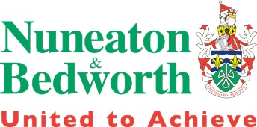 | Borough Plan Review  Main Modifications Representation  Form | Ref:  (For official  use only)

Name of the Local Plan to which this representation relates:
Borough Plan Main Modifications

Please return to Nuneaton and Bedworth Borough Council by 14th July 2025 via:
Email: planning.policy@nuneatonandbedworth.gov.uk
Post: Planning Policy Consultation, Town Hall, Coton Road, NUNEATON, CV11 5AA
This form has 2 parts:
Part A – Personal details
Part B – Your representation(s). Please fill in a separate sheet for each representation you wish to make.
Part A
 | - Personal details*  * If an agent is appointed, only the Title, Name and Organisation boxes in section 1. are required. Agent details should be completed in section 2. | 2. Agent’s details (if applicable)
Title
First name
Last name
Job title
(where applicable)
Organisation
(where applicable)
House number
Street
Town
Post code
Telephone number
Email address

