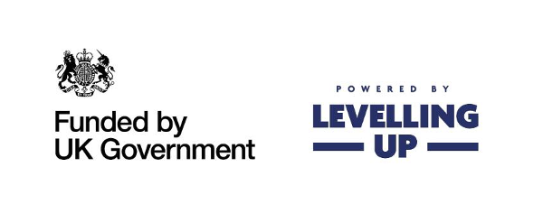

Nuneaton and Bedworth Community Safety Grant Scheme.

Guidance Notes
Please read the guidance notes carefully as they will help you decide whether you meet the criteria to apply to the Community Safety Grant Scheme and provide you with information on how to complete the application form.

Introduction
Your grant scheme will be funded, either partly or fully, by the UK government through the UK Shared Prosperity Fund. The purpose of the Community Safety Grant Scheme is to support organisations to deliver local initiatives and/or projects to benefit those living, working and visiting the borough. These initiatives or projects must contribute towards the priorities from the Nuneaton and Bedworth Community Safety Partnership (NABSCOP).
Nuneaton and Bedworth Community Safety Team are inviting organisations to bid for funding that supports one of more of the focus areas as detailed below:
- Reducing serious violence, including violence against women and girls
- Reducing domestic abuse
- Reducing anti-social behaviour
- Reducing hate crime

Who can apply?
Applications will be welcomed from both established and new community, voluntary, third sector and statutory organisations that deliver projects or services at a local level within Nuneaton and Bedworth.

Who cannot apply?
- Statutory, national organisations or individuals who are not working in partnership with local ‘not for profit’ groups.
- Party Political groups.

What will not be funded?
- Profit-making projects.
- Projects that promote religious or party-political beliefs.
- Activities that are part of statutory obligations or replace statutory funding including curriculum activities in schools.
- Projects which do not follow the Nuneaton and Bedworth Borough Council’s Equality and Diversity Policies and the national legislation on data protection, health and safety, discrimination, and child protection.
- Existing projects where evidence has not been provided to demonstrate impact and/or success.
- Retrospective projects, i.e. those have already taken place.

What supporting documents do you need to submit with your application?
- A copy of your constitution or set of rules.
- Financial report or last audited accounts and latest bank statement.
- Copies of any relevant insurance documentation.
- Copies of your Child Protection/ Vulnerable Persons/Safeguarding policies.
- A declaration of no conflicts of interest.
- A declaration that you have a UK bank/building society account in the name of the organisation applying for any responsible for managing the funds.

Application Process

- Community Safety Grant Fund Application Form 2023-2024 must be completed online via out website, www.nuneatonandbedworth.gov.uk.

Community Safety Grant fund- Criteria Briefs
Maximum grant bid per project; £5,000
Nuneaton and Bedworth Community Safety team invites applications for any project that aims to address one or more of the Community Safety Summit priorities. All applications should fund a one-off specific project.
You are welcome to discuss your project idea with the Communities Team or to ask for advice and information before you complete your application form. Please contact:
Contact details:
Samantha Bull - Senior Community Safety Officer
Telephone: 02476 376860
E-mail@samantha.bull@nuneatonandbedworth.gov.uk

You can also receive support in completing your application, and the supporting documents required, by contacting Warwickshire Community and Voluntary Action (WCAVA).
Address:
Newtown Centre
Nuneaton
CV11 4HG
Telephone: 024 7638 5765
E-mail: nbinfo@wcava.org.uk.

The panel will check applications to ensure they meet the eligibility criteria. In undertaking the assessment, we may request further information from applicants.
All successful projects will be required to enter into a Service Level Agreement and complete regular, reporting requirements on their project, including promotion and publicity, proof of project delivery, reporting around achieved outputs and outcomes and receipts for all money spent.

Successful applicants will be notified around the 11th October 2024 for arrangements for receipt of funding.

Funding stipulations
- All funds must be used by 31st March 2025. Any unused funds must be returned to Nuneaton and Bedworth Borough Council without delay.
- An end of project report must be submitted and received by Nuneaton and Bedworth Borough Council by the 1st May 2025.
- The Grant Recipient will use the Grant solely for the Funded Activities as detailed in the application. Any changes to the Project must be agreed in writing by way of a Variation Request with Nuneaton and Bedworth Borough Council before implementation. A Variation Request must include, details what has changed from your originally application and what purpose you are going to use the money for. Your request would need to be referred to the shortlisting board to ensure it still meets the priorities of the project. You will then be notified of the decision in due course.
- Failure to comply with the funding stipulations outlined above could result in legal action being taken against the grant recipient.

Deadline
The deadline for the Community Safety Fund application is end of play 30th September 2024. Applications will not be accepted after the closing date.

