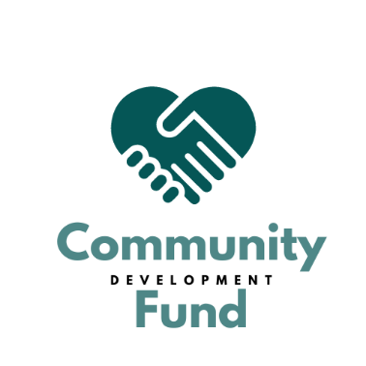

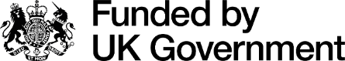

Nuneaton and Bedworth Community Development Fund.

Guidance Notes
Please read the guidance notes carefully. They will help you decide whether you can apply to the fund and provide you with information on how to complete the application form.
Introduction
The purpose of the Community Development Fund is to support organisations to deliver local initiatives or projects to benefit those living, working, and visiting the borough.
Nuneaton and Bedworth Communities Team is inviting organisations to apply for funding of up to £5000 for projects that support one or more of the following focus areas, as detailed below:
- Health and Wellbeing – projects that support and promote residents health and wellbeing (including physical, emotional, mental and sexual health).
- Stronger Communities – projects that support communities by improving existing community facilities, provide education and learning opportunities, celebrate and promote heritage.
- Youth Engagement - learning and engagement programmes specifically for people below the age of 25.
This grant scheme is funded by the UK government through the UK Shared Prosperity Fund.

Who can apply?
Applications will be welcomed from both established and new community, voluntary, third sector and statutory organisations that deliver projects or services at a local level within Nuneaton and Bedworth.
Applications will open on 22nd July 2024 and close at 5pm on 30th September 2024. Any applications received after this time will not be accepted.
Who cannot apply?
- Statutory or national organisations or individuals who are not working in partnership with local ‘not for profit’ groups in relation to the specific project that funds are being requested for
- Party Political Groups
What will not be funded?
- Profit-making projects
- Projects that promote religious or party-political beliefs
- Activities that are part of statutory obligations or replace statutory funding including curriculum activities in schools.
- Projects which do not follow the Nuneaton and Bedworth Borough Council’s Equality and Diversity Policies and the national legislation on data protection, health and safety, discrimination and child protection.
- Existing projects where there has been no evidence of impact or success
- Retrospective projects, i.e. that those have already taken place
- Core costs including staff costs, ongoing rental costs

What supporting documents do you need to submit with your application?
- A copy of your constitution or set of rules.
- Financial report or last audited accounts and latest bank statement.
- Copies of any relevant insurance documentation
- Copies of your Child Protection/ Vulnerable Persons/Safeguarding policies
- A declaration of no conflicts of interest.
- A declaration that you have a UK bank/building society account in the name of the organisation applying for any responsible for managing the funds.

Application Process
- Applications must be returned on the Community Development Fund Form 2024-2025 accessed via the Nuneaton and Bedworth Borough Council website (www.nuneatonandbedworth.gov.uk/community-fund)
- Applicants are free to submit any additional information in support of their application; however, this must not succeed two sides of A4 paper.

Community Development fund- Criteria Briefs
Maximum grant bid per project; £5,000
Nuneaton and Bedworth Communities team invites applications for any project that aims to address one or more of the specific priorities as detailed above. All applications should be for one-off funding for a specific project. Only one application per project may be made, and you may choose which NBBC fund you would like to apply for. You may apply to both grant schemes with two separate and distinct projects.
You are welcome to discuss your project idea with the Communities Team or to ask for advice and information before you complete your application form.
Contact details: communities@nuneatonandbedworth.gov.uk or call 02476 376376 and ask to speak to Rowena Musgrave.
You can also get further support in completing your application, and with the supporting documents required, from Warwickshire Community and Voluntary Action, Newtown Centre, Nuneaton CV11 4HG, 024 7638 5765, email nbinfo@wcava.org.uk.
The panel will check applications to ensure they meet the eligibility criteria. In undertaking the assessment, we may request further information from applicants.
All successful projects will be required to enter into a Service Level Agreement and complete regular, reporting requirements on their project, including promotion and publicity, proof of project delivery, reporting around achieved outputs and outcomes and receipts for all money spent.
Successful applicants will be notified around the week commencing 11th October 2024 for arrangements for receipt of funding.
Funding stipulations
- Any funds must be used by 31st March 2025. Any unused funds must be returned to Nuneaton and Bedworth Borough Council.
- An end of project report must be submitted and received by Nuneaton and Bedworth Borough Council by 1st September 2025.
- Failure to comply with the funding stipulations outlined above could result in legal action being taken against you.
- The Grant Recipient will use the Grant solely for the Funded Activities as detailed in the application. Any changes to the Project must be agreed in writing by way of Variation
Request with Nuneaton and Bedworth Borough Council before implementation. A Variation Request must include, details what has changed from your originally application and what purpose you are going to use the money for. Your request would need to be referred to the shortlisting board to ensure it still meets the priorities of the project. You will then be notified of the decision in due course.”

Deadline
The deadline for the Community Development Fund application is 5pm on Monday 30th September 2024. Applications will not be accepted after the closing date.

